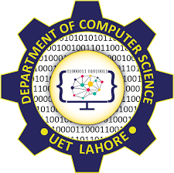
Internationally
Recognized

UET Graduates
Are Eligible
To Work
Globally As It VISIT US Is Associated ONLINE
To lms.uet.edu.pk
Washington cse.uet.edu.pk
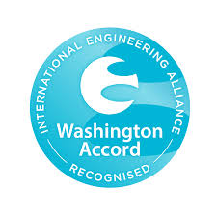
Accord.
Programs Offered
In
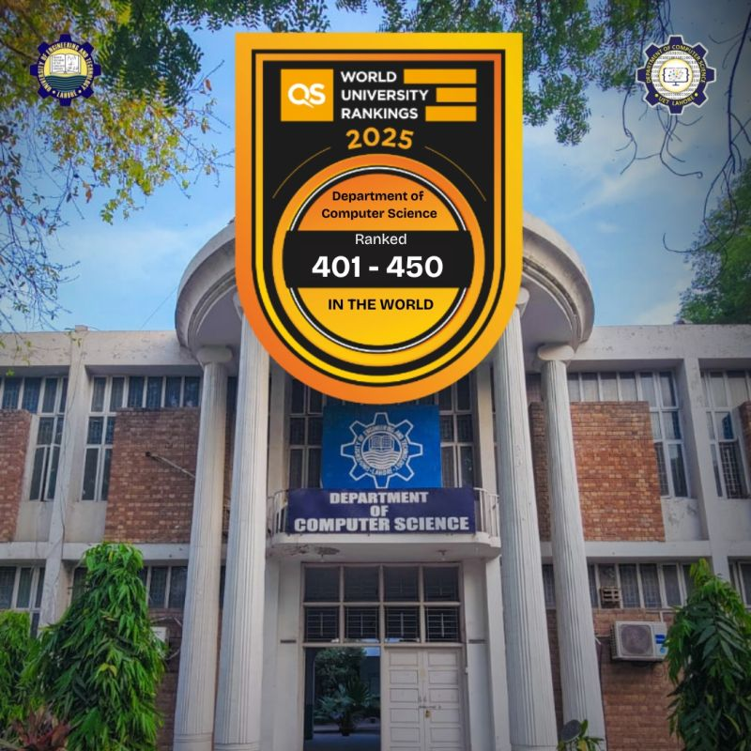
Computer Science
Department Are
Recognized By
Washington
Accord

